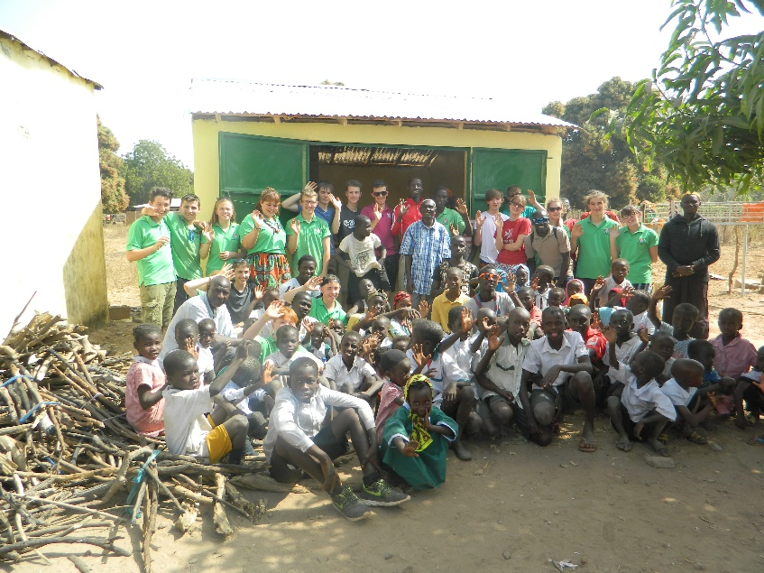
Expedition to The Gambia - Hampshire Scouts
Two weeks December 2026
WHERE? You guessed it.. to The Gambia. A small country on the west coast of Africa. From the capital Banjul on the Atlantic coast we take the bus 200 miles up country to SOMA, a dusty fly blown town at the junction of the two main (only) roads and stay at KAIRA KONKO Scout Lodge..

WHAT? Help improve the Kaira Konko Scout centre, repair school classrooms, repair local homes in Soma… take paper, books and pencils to the primary school… improve the vegetable garden in the village .. Friday night is Scout night and we will be there sharing ideas… help at the schools. PLUS shopping at the market. Visit the village chief.. go on expeditions out of Soma in small groups with the Gambian Scouts.. and LOADS MORE!!!!!

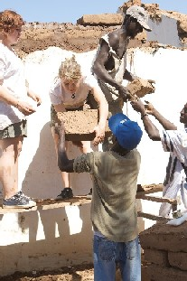
COST £2,300 TBC once flights are booked

WHEN? 2 weeks departing around 29th December 2026 return about Wed 13 January 2027. Note that you will need to arrange time off school/ college.

WHY?…WHY NOT? This is an amazing chance to experience the real Africa with your mates. It is excellent value. Try it out.. meet new friends check out some ideas for your GAP year, get something really impressive on your CV.

WHO?? Fantastic leaders, you, your friends, any Explorer/ Network aged 16-19 ( DOB between 01.09.2007 and 31.08.2011) who is prepared to give it a go (if they are not already a Scout then they had better join soon)

HOW? Lots of fund raising… for example, sponsored cycle, charity events, car washing … and exciting training so that you are ready for an adventure in Africa
Small print warning this trip could seriously change your outlook on life
Expedition to The Gambia
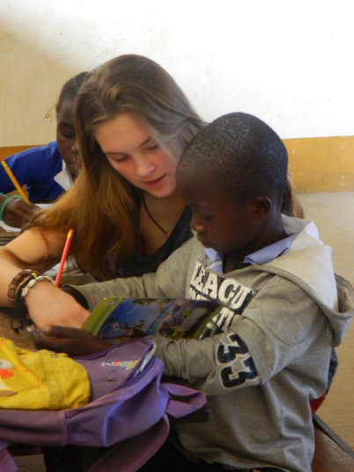
FUNDRAISING is an important part of the expedition

Fundraise a minimum of £1000, then either pay the remainder or fundraise as much as you can

TOTAL COST approx. £2,300 TBC
Deposit £300 then ten monthly payments

BACS PAYMENT Magellan Explorer Scouts
Account 71347810
Sort Code 404425

Includes flights accommodation, food, travel, visits, loads of laughs, masses of hard work, lots of sunshine and a few surprises, training, a polo shirt and international necker

Excludes vaccinations and anti-malarial tablets (full details will be provided about what you need nearer the time).

TRAINING
Please note this is a Scout Expedition. It is not a holiday. It will be challenging but very rewarding. The training is an important part of the expedition package and Explorers should prioritise it and make every effort to attend the training events.
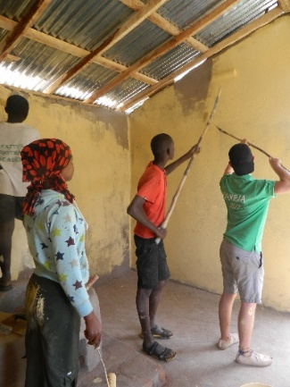
- Thurs 29 January 2026 Introduction Evening 7pm-9pm – Winchester TBC

- Thurs 26 February 2026 Online Parents Meeting 7pm-8pm

- 10am Sat 18 April – 4pm Sun 19 April 2026 Cardboard box camp Cranbury Park

- 7pm Fri 17 July – Sun 19 July 2026 – 4pm Training Weekend Tile Barn

- 7pm Fri 16th October - 2pm Sun 18th October parents meeting finish 3.30pm Training weekend & Parents-Pre-departure meeting Copythorne Scout Hut

For more information contact the Explorer Scout Leaders.

Jackie Heath, Expedition Leader Jackie.heath@live.co.uk 07918941708
Tishie Northcott & Paul Stubbington Deputy Expedition Leaders
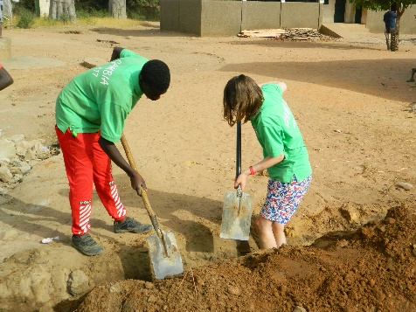
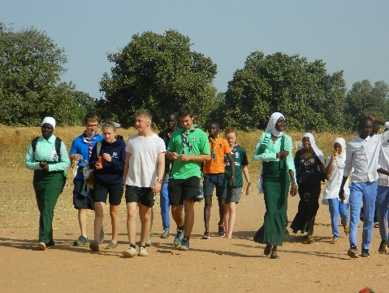
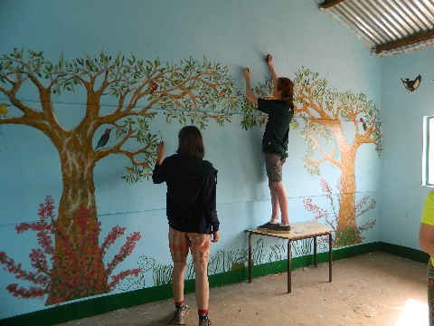

Please complete this google form…….. with the following information:
I would like to come on 2-week Gambia Expedition 29 December 2026 – 13 January 2027
Full Name as on passport ………………………………………………………………
Passport number ……………………………………………….and expiry date………….
Date of birth ……………………………… Age on 31st Dec 2026 …………………………………..
(Born between 1st September 2007 and 31st August 2011)
Explorer’s email address ………………………
Parents’ / guardian email addresses……………………………..
Your Unit and District…………………………………………….
Dietary requirements (inc vegetarian)
I confirm permission for photographs and video to be taken

A deposit of £50 to reserve a place and we will send a further £250 ASAP OR I enclose £300

Please tell us why you want to go and what you would like to get from the expedition?

What do we need to know about you? Tell us a bit about you ( school, hobbies, etc).

Please tell us briefly about anything that may affect our ability to keep you safe in the Gambia eg additional needs, allergies, chronic conditions, medication or anything else.

Return to an Explorer Leader. Places allocated on a first come basis.
Signed by parent or guardian………………………………………………………………..
Jackie.Heath@live.co.uk

